ASSIGNMENT: 13
NAME: P. Varshitha
BATCH: 14
HALL.TICKET.NO: 2503A52398
TASK: Use AI to refactor a given Python script that contains multiple repeated code blocks.

PROMPT: Refactor a Python program that calculates the area and perimeter of three rectangles. Identify repeated logic and replace it with a reusable function. Add a docstring to the function and ensure the output remains the same. Use the rectangle dimensions 5 and 10, 7 and 12, and 10 and 15.
INPUT:
def rectangle_calculations(length, width):
"""Calculate and display the area and perimeter of a rectangle."""
area = length * width
perimeter = 2 * (length + width)

print("Area of Rectangle:", area)
print("Perimeter of Rectangle:", perimeter)

rectangle_calculations(5, 10)
rectangle_calculations(7, 12)
rectangle_calculations(10, 15)
OUTPUT:
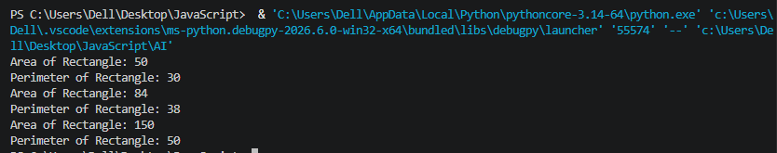

Task: Use AI to analyze a Python script with nested loops and complex conditionals.
PROMPT:
Analyze a Python program that searches for names in a list using nested loops. Optimize the program by replacing nested loops with set lookups. Maintain the same logic and output. Also compare the execution time of the original and optimized code using a performance comparison.
INPUT:
Analyze the following Python code and optimize it by replacing nested loops with set lookups. Keep the original logic and output unchanged. Also compare the execution time of the original and optimized code.

Code:
names = ["Alice", "Bob", "Charlie", "David"]
search_names = ["Charlie", "Eve", "Bob"]

for s in search_names:
found = False
for n in names:
if s == n:
found = True
if found:
print(f"{s} is in the list")
else:
print(f"{s} is not in the list")
OUTPUT:
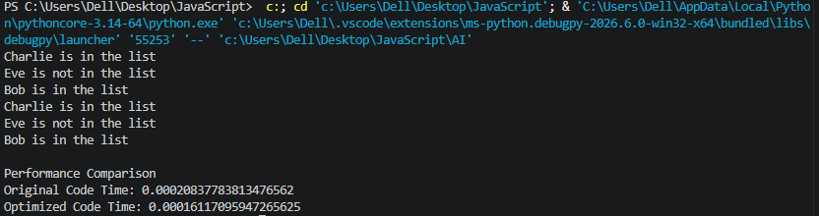

Task Description #3 (Refactoring – Extracting Reusable Functions)
Task: Use AI to refactor a legacy script where multiple calculations are embedded directly inside the main code block.
PROMPT:
Refactor a Python program that calculates the total price including 18% tax for multiple products. Extract the repeated calculations into a reusable function named calculate_total(price). Add a docstring and ensure the output remains the same.
INPUT:
Refactor the following Python code by extracting repeated calculations into a reusable function named calculate_total(price). The function should calculate 18% tax and return the total price. Add a docstring and maintain the same output.

Code:
price = 250
tax = price * 0.18
total = price + tax
print("Total Price:", total)

price = 500
tax = price * 0.18
total = price + tax
print("Total Price:", total)
OUTPUT:
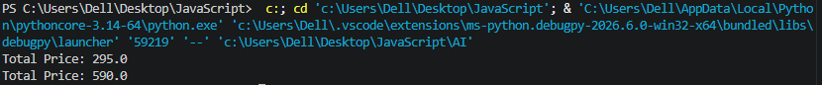
Task Description #4 (Refactoring – Replacing Hardcoded Values with Constants)
Task: Use AI to identify and replace all hardcoded “magic numbers” in the code with named constants.
PROMPT:
Refactor the following Python code by replacing hardcoded values with named constants. Create PI = 3.14159 and RADIUS = 7 at the beginning of the program. Use these constants to calculate the area and circumference of the circle. Maintain the same output.

Code:
print("Area of Circle:", 3.14159 * (7 ** 2))
print("Circumference of Circle:", 2 * 3.14159 * 7)
OUTPUT:
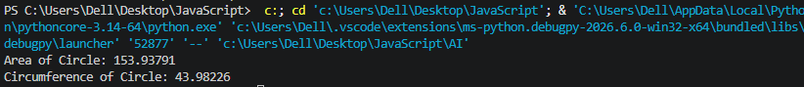

Task Description #5 (Refactoring – Improving Variable Naming and Readability)
Task: Use AI to improve readability by renaming unclear variables and adding inline comments.
PROMPT:
Improve the readability of a Python program that calculates the area of a triangle. Replace unclear variable names with meaningful names such as base, height, and area_of_triangle. Add explanatory comments and maintain the same functionality and output.
INPUT:
Improve the readability of the following Python code by replacing unclear variable names with meaningful names. Use base, height, and area_of_triangle as variable names. Add an explanatory comment and maintain the same functionality and output.

Code:
a = 10
b = 20
c = a * b / 2
print(c)

OUTPUT:

Task Description #6 (Refactoring – Removing Redundant Conditional Logic)
Task: Use AI to refactor a Python script that contains repeated if–else logic for grading students.
PROMPT:
Refactor a Python program that checks student marks and assigns grades. Remove repeated if-else conditions by creating a reusable function named calculate_grade(marks). Return Grade A for marks greater than or equal to 90, Grade B for marks greater than or equal to 75, and Grade C otherwise. Add a docstring and maintain the same output.
INPUT:
Refactor the following Python code by removing repeated if-else grading logic. Create a reusable function named calculate_grade(marks) with a docstring. The function should return Grade A for marks >= 90, Grade B for marks >= 75, and Grade C otherwise. Maintain the same output.

Code:
marks = 85
if marks >= 90:
print("Grade A")
elif marks >= 75:
print("Grade B")
else:
print("Grade C")

marks = 72
if marks >= 90:
print("Grade A")
elif marks >= 75:
print("Grade B")
else:
print("Grade C")
OUTPUT:
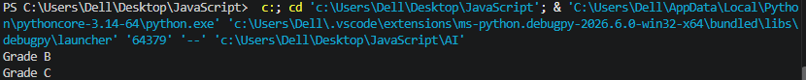
Task Description #7 (Refactoring – Converting Procedural Code to Functions)
Task : Use AI to refactor procedural input–processing logic into functions.
PROMPT:
Refactor a procedural Python program that accepts a number from the user and calculates its square. Divide the program into three separate functions: get_input(), calculate_square(), and display_result(). Add docstrings to all functions and maintain the same behavior and output.
INPUT:
def get_input():
"""Get a number from the user."""
num = int(input("Enter number: "))
return num

def calculate_square(num):
"""Calculate the square of a number."""
return num * num

def display_result(square):
"""Display the square result."""
print("Square:", square)

number = get_input()
result = calculate_square(number)
display_result(result)
OUTPUT:
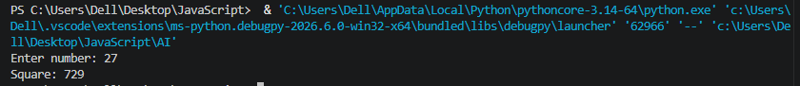

Task Description #8 (Refactoring – Optimizing List Processing)
Task: Use AI to refactor inefficient list processing logic.
PROMPT:
nums = [1, 2, 3, 4, 5]
squares = [n * n for n in nums]

print(squares)

OUTPUT:

